|  |  |  |
| --- | --- | --- |
| Roll Number | Registration Number | Name |
| 19 | 12402551 | Manas Awasthi |
| 18 | 12401941 | Yash Saraswat |
| 3 | 12411802 | Kanishka Garg |
| 20 | 12403728 | Yogeshwar |

**Introduction:** Humidity and temperature are common parameters to measure environmental conditions. In this Arduino based project we are going to measure ambient temperature and humidity and display it on a LCD screen. A combined temperature and humidity sensor DHT11 is used with Arduino uno to develop this Celsius scale thermometer and percentage scale humidity measurement project. This project consists of three sections - one senses the humidity and temperature by using humidity and temperature sensor DHT11. The second section reads the DHT sensor module’s output and extracts temperature and humidity values into a suitable number in percentage and Celsius scale. And the third part of the system displays humidity and temperature on LCD.

**Components:**

1. **Arduino:** Arduino is an open-source electronics platform based on easy-to-use hardware and software. Arduino boards are able to read inputs - light on a sensor, a finger on a button, or a Twitter message - and turn it into an output - activating a motor, turning on an LED, publishing something online**.**
2. **Arduino Uno:** Uno can be used to build many projects, including LED blinkers, Robots etc. It consists of various pins, which makes it more compatible and can be used to connect different electronic components Arduino.
3. **DHT 11:** DHT11 is a low-cost digital sensor for sensing temperature and humidity. This sensor can be easily interfaced with any micro-controller such as Arduino, Raspberry Pi etc… to measure humidity and temperature instantaneously. DHT11 humidity and temperature sensor is available as a sensor and as a module.
4. **Liquid Crystal i2c LCD:** The LiquidCrystal_I2C library allows you to program an Arduino to print messages to an LCD screen using an I2C backpack.I2C is a communication protocol that allows you to communicate with multiple devices using only a few pins.

**Circuit Diagram:**

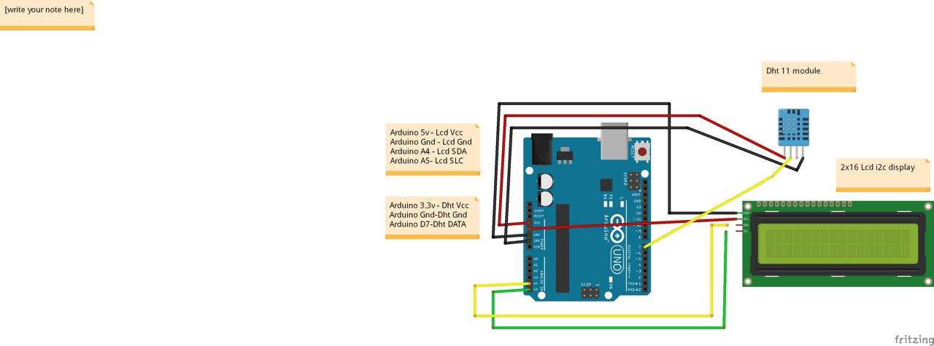

**Functionality:** In this project, we will build a small circuit to interface Arduino with DHT11 Temperature and Humidity Sensor. One of the main applications of connecting DTH11 sensor with Arduino is weather monitoring. All the DHT11 Sensors are accurately calibrated in the laboratory and the results are stored in the memory. A single wire communication can be established between any microcontroller like Arduino and the DHT11 Sensor. Also, the length of the cable can be as long as 20 meters. The data from the sensor consists of integral and decimal parts for both Relative Humidity (RH) and temperature. The data from the DHT11 sensor consists of 40 – bits. The DHTxx sensors have four pins, VCC, GND, data pin and a not connected pin which has no usage. A pull-up resistor from 5K to 10K Ohms is required to keep the data line high and in order to enable the communication between the sensor and the Arduino Board. There are some versions of these sensors that come with a breakout boards with built-in pull-up resistor and they have just 3 pins.

**Conclusion**: It is evident from this project work that Temperature and Humidity Sensor Project can be cheaply made from low-cost locally available components and be used to monitor and control the temperature and humidity at the data center. And better still, the components required are so small and few that they can be packaged into a small container. The designedproject wastested a number of times and certified to achieve the aim of the project. This Temperature and Humidity Sensor Project can also be done using the esp8266 or various other sensors. Hence, this system is scalable and flexible.